**Western Australian Certificate of Education**

**Semester 2 Examination, 2022**

Please place your student identification label in this box (if required)

**ENGLISH**

## Year 12 ATAR: Units 3 & 4

|  |  |  |  |  |  |  |  |  |  |  |  |  |
| --- | --- | --- | --- | --- | --- | --- | --- | --- | --- | --- | --- | --- |
| Student Number: | In figures |  |  |  |  |  |  |  |  |  |  |  |
|  | In words |  |  |  |  |  |  |  |  |  |  |  |
|  |  |  |  |  |  |  |  |  |  |  |  |  |

## Time allowed for this paper

Reading time before commencing work: ten minutes

Working time: three hours

## Materials required/recommended for this paper

***To be provided by the supervisor***

This Question booklet  
Answer booklet(s)

***To be provided by the candidate***

Standard items: pens (blue/black preferred), pencils (including coloured), sharpener, eraser, correction fluid/tape, ruler, highlighters

Special items: nil

**Important note to candidates**

No other items may be taken into the examination room. It is **your** responsibility to ensure that you do not have any unauthorised material. If you have any unauthorised material with you, hand it to the supervisor **before** reading any further.

## Structure of this Paper

|  |  |  |  |  |  |
| --- | --- | --- | --- | --- | --- |
| Section | Number of questions available | Number of questions to be answered | Suggested working time (minutes) | Marks available | Percentage of examination |
| Section One: Comprehending | 3 | 3 | 60 | 30 | 30 |
| Section Two: Responding | 6 | 1 | 60 | 40 | 40 |
| Section Three: Composing | 5 | 1 | 60 | 30 | 30 |
|  |  |  |  | **Total** | 100 |

## Instructions to candidates

1. The rules for the conduct of the Western Australian Certificate of Education ATAR course examinations are detailed in the *Year 12 Information Handbook 2022: Part II Examination*. Sitting this examination implies that you agree to abide by these rules.
2. Write your answers in the spaces provided in this Question/Answer booklet.
3. You must be careful to confine your answers to the specific questions asked and to follow any instructions that are specific to a particular question.
4. Additional working space pages at the end of this Question/Answer booklet are for planning or continuing an answer. If you use these pages, indicate at the original answer, the page number it is planned/continued on and write the question number being planned/continued on the additional working space page.
5. You must not use texts from Section One to answer questions from Section Two.

## Section One: Comprehending 30% (30 marks)

In this section there are **three** texts and **three** questions. Answer **all** questions.

You are required to comprehend and analyse unseen written and visual texts and respond concisely in approximately 200–300 words for each question.

Suggested working time: 60 minutes.

**Question 1** (10 marks)

Analyse how language features are used to achieve a purpose in **Text 1.**

**Question 2** (10 marks)

Explain how generic conventions in **Text 2** have been used to convey an idea about the future.

**Question 3** (10 marks)

How is your interpretation shaped by the construction of **Text 3**?

**Text 1**

*Text 1 is an extract from the introduction for an anthology of short stories titled: The Best Australian Stories 2017 published by Black Inc. The introduction was written by the editor of the anthology, Maxine Beneba Clarke.*

Writing the perfect short story is like skimming a stone. There’s the testing and selection of material: the running of thumb over smoothness of surface; the weighing of rock in palm. There’s the framing of the story: the selection of angle and entry point, just so. The side-tilt of the body; the squint against the sun; the raising of the hand; the assessment of the water; the pace of the throw. The let-go. Then, after all these things have aligned into perfect overall technique, there’s just that little bit of luck. How far will the stone travel? How many jumps will it make across the surface? How wide will the ripples be when it connects with water, and how deep will they run? And, at the end of it all, did it seem like just a casual throw?

Junot Díaz. J. California Cooper. Nam Le. Alice Munro. James Baldwin. Cate Kennedy. William Faulkner. David Malouf. The best short fiction writers place their pens down and leave you with a haunting: a deep shifting of self, precipitated by impossibly few words. The challenge, then, as an editor was to carefully locate those stories which so sung, among the hundreds upon hundreds of excellent stories encountered.

In Dominic Amerena’s ‘Help Me Harden My Heart’, there is the sharp intake of breath as a handful of decades-old baby teeth are scattered across a kitchen; there is the gut-punch shock of vile words, spat from the mouth of a teenager who grew up alongside yours. Cassie Hamer’s ‘By Proxy’ captures the overwhelming uncertainty of leaving home for unknown shores. This story is at once unique and universal. The mass movement of people around the world and the precarious position of women in such transits are both age-old issues and contemporary concerns. In Melissa Lucashenko’s ‘Dreamers’, the author paints an unforgettable portrait of strangers, bound by love and loss to become family. Lucashenko’s story is a masterful exercise in restraint, letting unspoken histories echo through. In Verity Borthwick’s ‘Barren Ground’, we become uncomfortably complicit in the protagonist’s uncertainty about saving the life of a person she has deeply loved.

These stories push and pull at our hearts, demanding entry into their chambers. These stories vary from the surreal to the naturalistic, from the satirical to the poignant, from loud declaration to murmured whisper. They are delivered by achingly familiar voices, and attached to author names I had never before encountered. They were published in leading Australian literary journals, anthologies and newer publications, or have not yet been published. Taken together, these stories also sing of the country that we are. Of our history, and our hopes; our battles and our dreams.

**Text 2**

*Text 2 is the exposition of Corey Pressman’s novel, Divided Light. The story is set in a future where Phoenix, Arizona is under a covering that collects solar power. It was published by the Center for Science and the Imagination, Arizona State University, in 2018.*

My friends and I headed out early; it was a few hours’ ride to the Oasis from Shade City. We pulled out of town on the eastern expanse, through our dappled neighborhood, where the great solar shade that covered the central city offered the variegated light that fetched high rents, touristy cactus labyrinths, and the best golf. Being young and offensive, we were sure to obey zero traffic laws as we sped through the outer city, where the shade ran out and our unfortunate neighbors wallowed in the dazzle of full sun most of the day.

We blazed out into open desert. Looking back, Shade City’s solar ceiling dominated the horizon, reaching up and out as far as I could see. Looking forward, the Ramish settlements were almost invisible: small holdings dotting the landscape, a single slice of green the only clear indication of human habitation. Even the photon farms seemed to blend into the desert.

It was my eighteenth birthday, and we were headed to the Ramish Oasis so I could participate in a new but noble tradition: dunking my now-adult self in the deep Dragon Tree root pools at the center of the Ramish settlement. These desert *denizens1* possessed some genius for biology and air: they engineered giant Dragon Trees that rooted to the *aquifer2* and drew pools of cold water to the surface. Each mined the sky for humidity, one drop at a time, sloping the water down to glimmering oasis pools.

I had never seen a body of water larger than a sink. I had never done more than splash myself with handfuls of lukewarm water. I had never immersed. Can you imagine, children?

We pointed the buggy at the winking green mirage ahead and partied hard as The Thumb grew hazy behind us. The Thumb—that’s what we called Shade City, or, to be precise, the huge solar-panel sunshade that Umbra Corporation was erecting over town. The giant structure gave us life: it gave us cool shade and clean power. It gave us a way to survive, and to attract people back to New Phoenix, which hadn’t fared well in the flare years. But it also evoked a sort of dread. It was a hovering menace. It was The Thumb.

1denizens- a person, animal, or plant that lives or is found in a particular place.

2aquifer- a body of rock and/or sediment that holds groundwater.

**Text 3**

*Text 3 is a greyscale reproduction of the promotional poster for the documentary Last Man Fishing* (2019). *The documentary focuses on small-scale fishermen across America fighting for the right to continue their trade.*

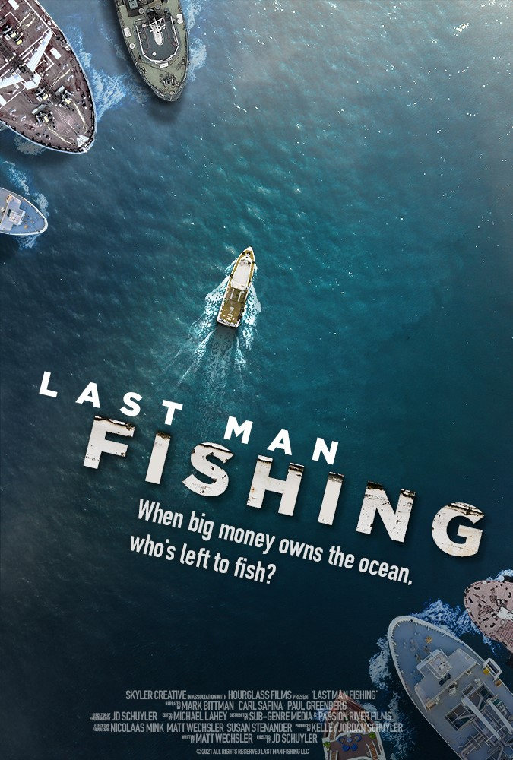

**End of Section One**

## Section Two: Responding 40% (40 Marks)

In this section there are **six** questions. Answer **one** question.

Your response should demonstrate your analytical and critical thinking skills with reference to any text or text type you have studied.

Suggested working time: 60 minutes.

**Question 4** (40 marks)

Discuss how a text can be read in multiple ways depending on the context of the audience.

**Question 5** (40 marks)

Through a comparison of **two** texts, evaluate the effectiveness of their differing approaches to representing an idea.

**Question 6** (40 marks)

Explore the relationship between the underlying assumptions and values and the perspective/s represented in **one** text.

**Question 7** (40 marks)

Compare how the voices in **two** texts have been constructed to resonate with the concerns of their audiences.

**Question 8** (40 marks)

Explain how your understanding of genre has informed your interpretation of a multimodal text.

**Question 9** (40 marks)

With reference to at least **one** text, discuss how language and structural features work together to communicate a complex viewpoint on an issue.

**End of Section Two**

## Section Three: Composing 30% (30 Marks)

In this section there are **five** questions. Answer **one** question.

You are required to demonstrate writing skills by choosing a form of writing appropriate to a specific audience, context and purpose.

Suggested working time: 60 minutes.

**Question 10** (30 marks)

Compose a persuasive text with the intent of alarming a disengaged audience.

**Question 11** (30 marks)

Craft an imaginative text in which the central conflict is inspired by the following line:

“Every villain is a hero in his own mind.”

― Tom Hiddleston

**Question 12** (30 marks)

Create a text within a particular genre that explores a theme suggested by the following image.

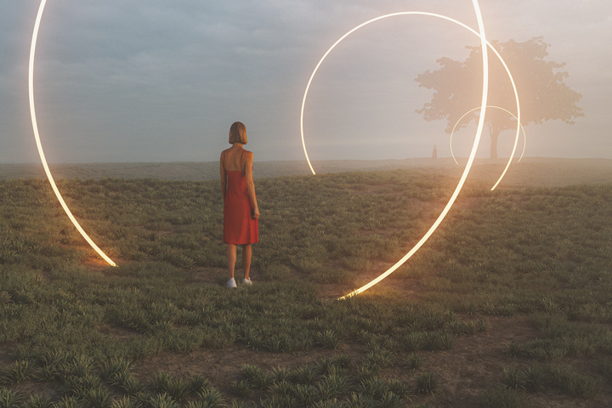

**Question 13** (30 marks)

Compose two interpretive extracts which sustain different voices related to the same contemporary concern.

**Question 14** (30 marks)

In the form of your choice, construct a text that innovates with language or structure to comment on an established cultural understanding.

**End of Questions**

**ACKNOWLEDGEMENTS**

|  |  |
| --- | --- |
| **Text 1** | Clarke, M.,(2017), The Best Australian Stories 2017. Black Inc. Publishing. Reproduced with permission. |
| **Text 2** | Pressman, C., (2018), Divided Light. Center for Science and the Imagination Arizona State University. Reproduced with permission. |
| **Text 3** | The Last Man Fishing promotional poster, Retrieved May, 2022 from: [https://lastmanfishing.com](https://lastmanfishing.com/) Reproduced with permission. |
| **Question 11** | “Every villain is a hero in his own mind.” Tom Hiddleston. Quote retrieved June, 2022 from: <https://allauthor.com/quotes/195116/> |
| **Question 12** | Image retrieved June 2022 from iStockphoto: <https://www.istockphoto.com/en/photo/fantasy-landscape-with-passage-through-different-universes-gm1200558585-343931211>. Reproduced with permission. |